# Project Name: Zombie Dice

# Team Name: Random Expletive on Execution

## Team Members:

Brandon Huebert

Timothy Ater

Michael Mandang

Umair Tahir

Francisco Rivas

Brian Watson

### Project Overview:

Our plan for this project is to build an online version of the tabletop dice game ‘Zombie Dice’. In this game, two players faceoff to be the first to consume a total of 13 brains. Logged in players take turns rolling virtual dice from the dice pool, while the application tracks scores, turns, etc. Once a winner is determined, game statistics are stored in the database. The game is played using a web browser in real-time, and no page refreshing would be required until the game is completed.

### Game Rules – Simplified Version:

On a player’s turn, they receive three six-sided dice. Each die has three possible sides: feet, shotgun, brains.

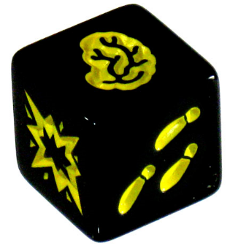

* Die Roll Probabilities (Six-sided):   
  2 Brain sides, 2 Feet sides, 2 Shotgun sides

The player rolls their dice and continues to roll, setting aside (counting) each brain and shotgun they roll (and replenishing back up to three dice each time), until either three shotguns are rolled or the player decides to end their turn. If three shotguns are rolled prior to the player ending their turn, all brains counted this turn are forfeit. The player has the choice to stop after each roll, and score the brains they have rolled so far. When they decide to stop, play passes to the next player.

Play continues until a player scores a total of 13 brains (or higher). The basic strategy of the game is to stop rolling before you roll three shotguns.

### Implementation Overview

* Technologies: Node.js, Express, MongoDB, HTML/CSS, Javascript

### Sample Database Structure

Players = {username, password, wins, losses}

Games = {player1, player2, winner}